**Important information for application**

Applications will be accepted only via via [**https://karriere.charite.de/en/job-vacancies/detail/4344**](https://karriere.charite.de/en/job-vacancies/detail/4344)during the application period.

Online interviews or interviews at the Institute in Berlin with selected candidates will be scheduled.

If you have any questions or encounter any problems when preparing your application please don't hesitate to contact us.

**Requirements**

RTG PhD applicants are required to have a diploma, master degree or comparable degree in a biomedical discipline with grade “very good” or “good”.

Formal requirements for the acceptance as PhD student are:

1) Master degree (or comparable) in a relevant subject from a University listed and positively rated by the “anabin” database of the “Kultusminister Konferenz” (http://anabin.kmk.org/)

2) a total of 300 ECTS credit or equivalent for obtaining the Master degree

(https://en.wikipedia.org/wiki/European_Credit_Transfer_and_Accumulation_System)

3) a thesis project as part of the Master degree

4) a final mark of at least “2” (good) as calculated by the “Bayerische Formel”:

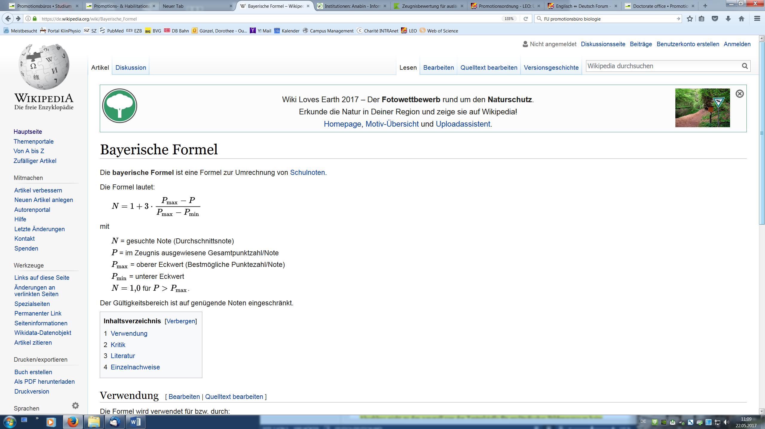

N: final equivalent mark within the German system

P: final mark of the student in his/her institution’s system

Pmax: best possible mark of the foreign institution

Pmin: lowest possible mark (above fail) of the foreign institution

Applications are also welcome if the required degree has not yet been awarded by the time of application. However, this must have been conferred **before** the official start of the project.

Applicants who are not native English speakers are encouraged, but not required, to submit TOEFL or IELTS certificates with their applications. For admission to the doctorate a proof of the language skills (English level B2) may be necessary.

**Application**

1) The application has to be in English language (application form, CV). The application form and the project descriptions are available at **<https://klinphys.charite.de/personen/guenzel.htm>**.

2) All submitted transcripts and certificates must be in English or German. Certified copies of documents are not mandatory in the application. However, for admitted students all relevant documents have to be certified.

3) The application must include the relevant university examinations (Master's and Bachelor's degree, or German *Diplom* and *Vordiplom*). If your final certificates are not available for your application, please submit provisional certificates and send final certificates as soon as available. Final certificates must be submitted for your employment. Please also include your final certificate of secondary school education (*Abitur*, *Matura*, or equivalent) which gives the right of admission to university. Please include an explanation of the grading system for this certificate.

4) The application must include reference letters of two academic teachers/supervisors.

5) Please submit your application via [**https://karriere.charite.de/en/job-vacancies/detail/4344**](https://karriere.charite.de/en/job-vacancies/detail/4344)by February 28, 2025.

**Checklist for your application**

* Completed Application Form
* Curriculum vitae (1 page)
* Transcripts, records of study
* Certificates: Master (or Diploma), Bachelor, secondary school education, English language test (if available, not mandatory)
* Reference letters of two academic teachers/supervisors

**Application process**

We will select applicants for presentations an online meeting. We expect a short presentations of the Master/Diploma thesis followed by a discussion. After the online presentation, selected candidates will be invited for further interviews either in person or online.

A final decision regarding the acceptance will be announced at the latest by the end of March 2025. All students will be informed about the decision by email. Selected PhD students will receive a work contract and may start their PhD project immediately after completing all formalities. There are no tuition fees. However, PhD students are required to enroll at one of local universities with a contribution of ~ 50 € / month for which they will receive a ticket for free public transport in Berlin and surrounding areas.